**УКАЗАТЕЛЬНЫЕ МЕСТОИМЕНИЯ. DEMONSTRATIVE PRONOUNS**

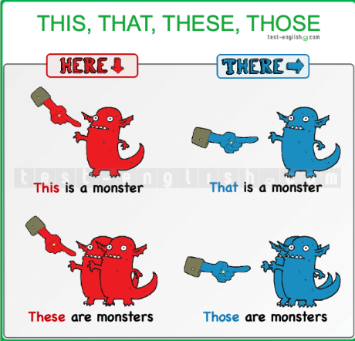**this/these** === *here* **that/those** === *there*

*We use* ***this*** *and* ***these*** *for things that are here (near).* ***This*** *is singular and* ***these*** *is plural.*

*This is my new watch.*

*These are my sisters Anna and Jenny.*

*We use* ***that*** *and* ***those*** *for things that are there (not near).* ***That*** *is singular and* ***those*** *is plural.*

*That man is very strange.*

*I need those boxes over there.*

*We can use* ***this****,* ***that****,* ***these****,* ***those*** *with a noun (this box, that car, etc.) or without a noun.*

*This watch is very expensive.*

*I like that woman in the park.*

*Who is that? (= that person)*

*‘What are those?’ ‘They are old pictures.’*

*We use* ***this*** *is when we introduce people and on the telephone*

*Hi, this is Tim. (Tim on the telephone)*

*Laura: ‘Hi, Sara. This is my friend Paul.’ Sara: ‘Hi, Paul. Nice to meet you.’*

*We use* ***this is*** *... and* ***is that... ?*** *on the phone*

*Hi Sarah, this is David.*

*(this = the speaker)*

*Is that Sarah?*

*(that = the other person)*

***that*** *=== something that has happened*

*I’m sorry I forgot to phone you.' 'That's all right.'*

*That was a really nice meal. Thank you very much.*

***that*** *=== what somebody has just said*

*'You're a teacher, aren't you?' 'Yes, that's right.'*

*'Martin has a new job.' 'Really? I didn't know that.'*

*I’m going on holiday next week.' 'Oh, that's nice.'*